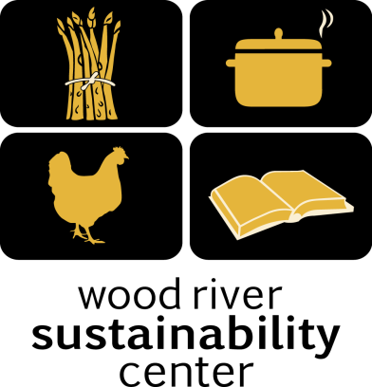

Local Food – Local People
Syringa Mountain School
Lunch Program October 2017

Monday, October 2nd
Veggie Alfredo
Creamy Cheese Sauce and Penne Noodles with Sourdough Bread With onions, garlic, spinach Tomatoes and Green Salad

Tuesday, October 3rd
Taco Salad
with Roasted Tomato Salsa and Queso Fresco, Corn & Beans Salad
Includes onions, jalapeños, garlic, tomato and cilantro & Corn tortillas. Gluten free!

Wednesday, October 4th
Chicken Caesar salad
with Sourdough Croutons, Includes egg, Tabasco olive oil, Dijon & lemon juice,
Dijon and anchovies in dressing. Parmesan cheese. Gluten Free except Croutons
Thursday, October 5th
Vegetable Soup
with Beans, Corn, Peas, Onions, Garlic and Carrots with Sourdough Bread and Green Salad

Friday, October 6th
Chicken Alfredo
With Chicken, Creamy Cheese Sauce and Penne Noodles with Sourdough Bread and Green Salad

Monday, October 9th
Tomato and Basil Bisque
with Sourdough Bread and Green Salad, Includes garlic, olive oil and onion. Gluten Free except sourdough. Vegetarian.

Tuesday, October 10th
Taco Salad
with Grass Fed Beef, Roasted Tomato Salsa and Queso Fresco, Rice and Beans
Includes onions, jalapeños, garlic, tomato and cilantro & Corn Tortilla Chips. Gluten free!

Wednesday, October 11th
Chicken Noodle Soup
Chicken, celery, carrots and Green Salad

Thursday, October 12th
Veggie Alfredo
Creamy Cheese Sauce and Penne Noodles with Sourdough Bread With onions, garlic, spinach Tomatoes and Green Salad

Friday, October 13th
Spaghetti Bolognese Bake
with Sourdough Bread and Green Salad, Includes olive oil, red wine vinegar and herbs.

WRSC 308 S. River St. wrsustainabilitycenter@gmail.com 208-721-3114
Monday, October 16th
Tomato and Basil Bisque
with Sourdough Bread and Green Salad, Includes garlic, olive oil and onion. Gluten Free except sourdough. Vegetarian.

Tuesday, October 17th
Taco Salad
with Grass Fed Beef, Roasted Tomato Salsa and Queso Fresco, Rice and Beans
Includes onions, jalapeños, garlic, tomato and cilantro & Corn Tortilla Chips. Gluten free!

Wednesday, October 18th
Chicken Enchiladas
with Chicken, Onions, peppers, cheese and tomatoes. With a Green Salad

Thursday, October 19th
No School
Teacher in Service

Friday, October 20th
No School
Teacher in Service

Monday, October 23rd
Veggie Alfredo
Creamy Cheese Sauce and Penne Noodles with Sourdough Bread With onions, garlic, spinach Tomatoes and Green Salad

Tuesday, October 24th
Taco Salad
with Roasted Tomato Salsa and Queso Fresco, Corn & Beans Salad
Includes onions, jalapeños, garlic, tomato and cilantro & Corn tortillas. Gluten free!

Wednesday, October 25th
Chicken Pot Pie
With Chicken, Corn, Peas, Green Beans, Carrots, Celery and Potatoes.

Thursday, October 26th
Vegetable Soup
with Beans, Corn, Peas, Onions, Garlic and Carrots with Sourdough Bread and Green Salad

Friday, October 27th
Chicken Alfredo
With Chicken, Creamy Cheese Sauce and Penne Noodles with Sourdough Bread and Green Salad

Monday, October 30th
Tomato and Basil Bisque
with Sourdough Bread and Green Salad, Includes garlic, olive oil and onion. Gluten Free except sourdough. Vegetarian.

Tuesday, October 31st
Taco Salad
with Grass Fed Beef, Roasted Tomato Salsa and Queso Fresco, Rice and Beans
Includes onions, jalapeños, garlic, tomato and cilantro & Corn Tortilla Chips. Gluten free!

WRSC 308 S. River St. wrsustainabilitycenter@gmail.com 208-721-3114

